E-Commerce Product Analysis and Prediction Using Clustering and Machine Learning

1. Introduction
The rapid growth of e-commerce platforms has led to the vast volumes of product-related data, including pricing information, customer ratings, and review metrics. Platforms such as Flipkart host thousands of products across diverse product categories, with frequent fluctuations in prices and popularity. However, much of this valuable information is available only in unstructured web formats, which limits its direct use for analysis and predictive modeling.
This capstone project aims to design and implement a complete end-to-end data science pipeline using Python for web data extraction and preprocessing, SQL (MySQL) for structured data storage, and Machine Learning techniques for predictive analysis. The project focuses on converting raw web data into structured datasets and deriving meaningful insights to support data-driven business decision-making.
2. Problem Statement
Despite the availability of large volumes of product data on Flipkart, the following challenges persist:
- Product data on Flipkart is largely unstructured and scattered across multiple web pages
- Manual data analysis is time-consuming, inefficient, and prone to errors
- There is no centralized relational database for effective data storage and analytics
- Predictive insights into product popularity and pricing trends are lacking
- Identifying high-performing and low-performing products is difficult
To overcome these challenges:
- A scalable and automated data science solution is required
- The solution should leverage Python for data extraction and processing
- SQL (MySQL) should be used for structured data storage and querying
- Machine Learning techniques should be applied for predictive analysis

3. Objectives of the Project
The key objectives of the project are:
- To collect product-related data from Flipkart using Python-based web scraping
techniques.
- To clean, preprocess, and transform raw web data into a structured and analysis-
ready format.
- To design and implement a relational database using MySQL for efficient data
storage and retrieval.
- To perform Exploratory Data Analysis (EDA) to uncover patterns, trends, and
relationships within the data.
- To apply Machine Learning models for prediction and classification tasks.
- To evaluate model performance using appropriate statistical and performance
metrics.
- To derive actionable insights that support data-driven decision-making.
4. Dataset Description
The dataset was created by scraping product information from Flipkart e-commerce website.
4.1 Attributes Collected:
- Product Name
- Price
- Category
- Ratings
- Number of Reviews
4.2 Products Collected:
- Mobiles
- Electronics
- Laptops
- Television
- Vechicles
5. Methodology
5.1 Web Scraping
- Selected Flipkart, a major e-commerce platform, as the data source for product information.
- Implemented web scraping using Python and Selenium WebDriver to handle dynamic, JavaScript-rendered content.
- Automated browser navigation to iterate through multiple result pages using pagination.
- Used explicit waits to ensure elements were fully loaded before extraction.
- Applied exception handling to manage missing or unavailable data and ensure uninterrupted scraping.
- Stored the extracted data into Python lists and later exported it to a CSV file for preprocessing and analysis.
5.2 Data Cleaning and Exploratory Data Analysis (EDA)
The scraped data was cleaned using pandas library:
- Identified and appropriately handled missing values
- Removed duplicate records and irrelevant data entries
- Standardized currency formats and normalized text casing
- Converted numerical attributes to their appropriate data types.
- Checked for negative rating values to identify potential data quality issues.
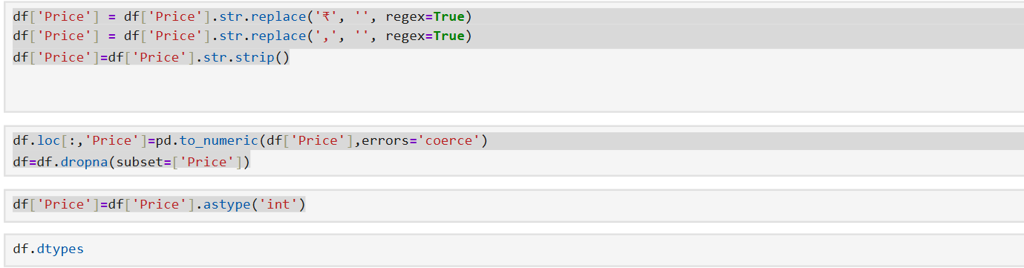
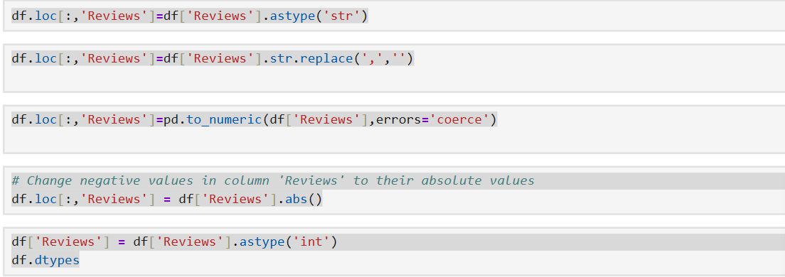
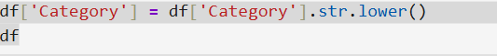

  - Exloratory Data Analysis(EDA)
- Average price by category.
- Average Rating vs Reviews by Category
- Price Distribution
- Correlation heat map
- Outliers Analysis
EDA helped uncover initial trends and guided feature selection for modeling.
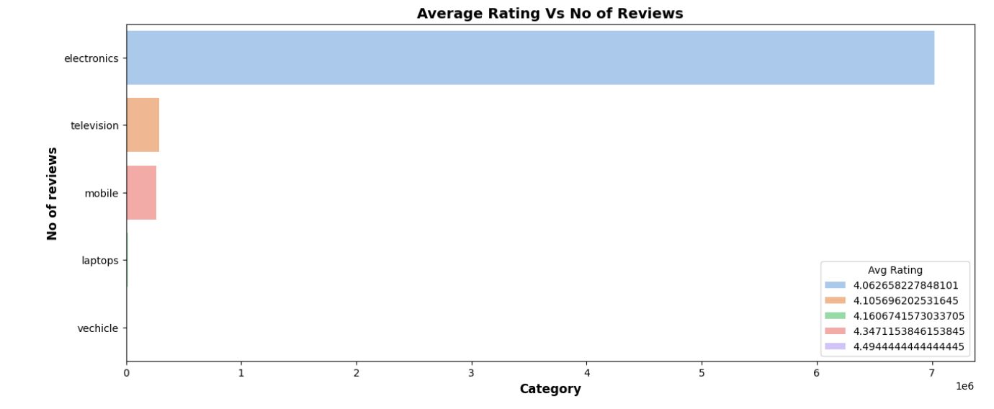
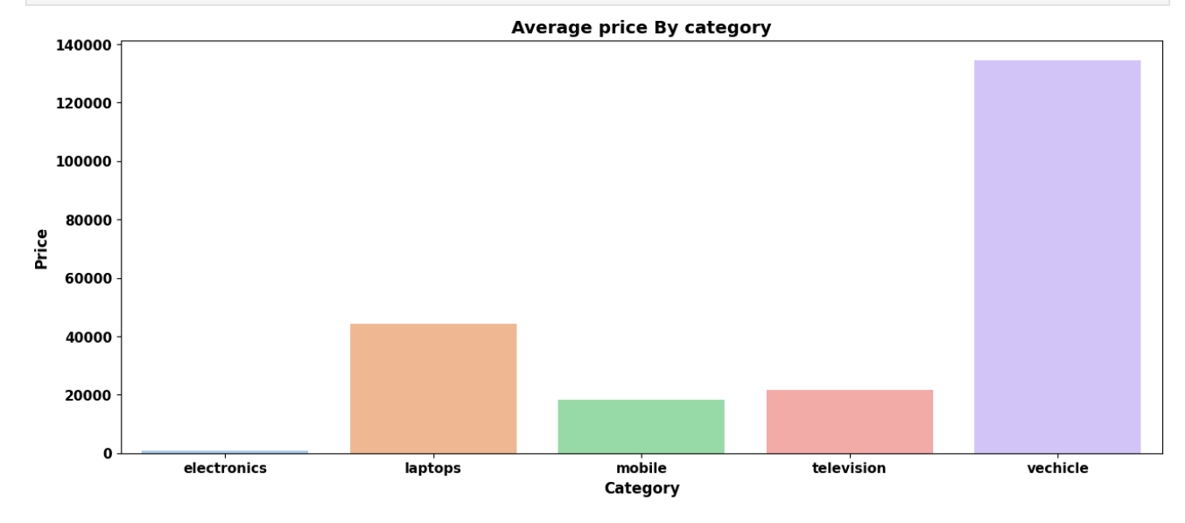

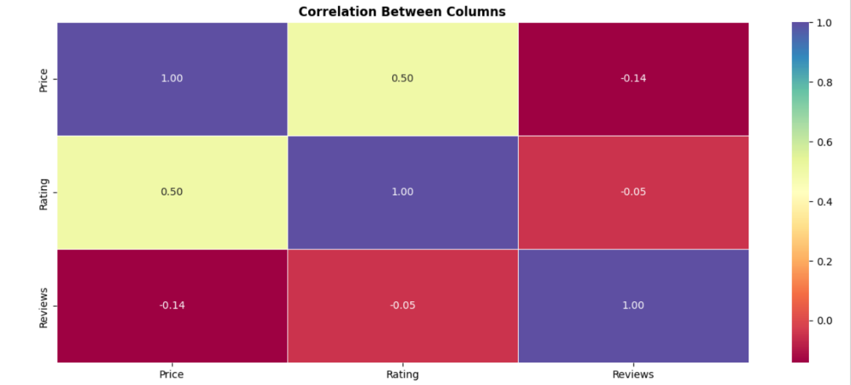
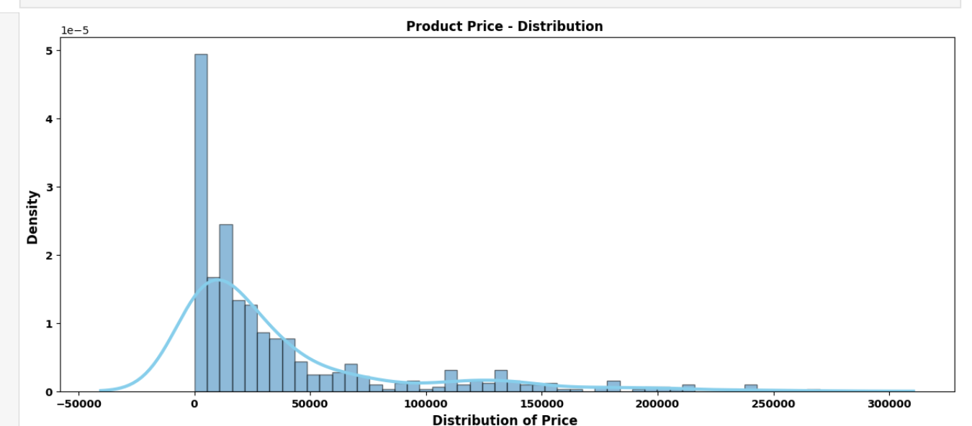

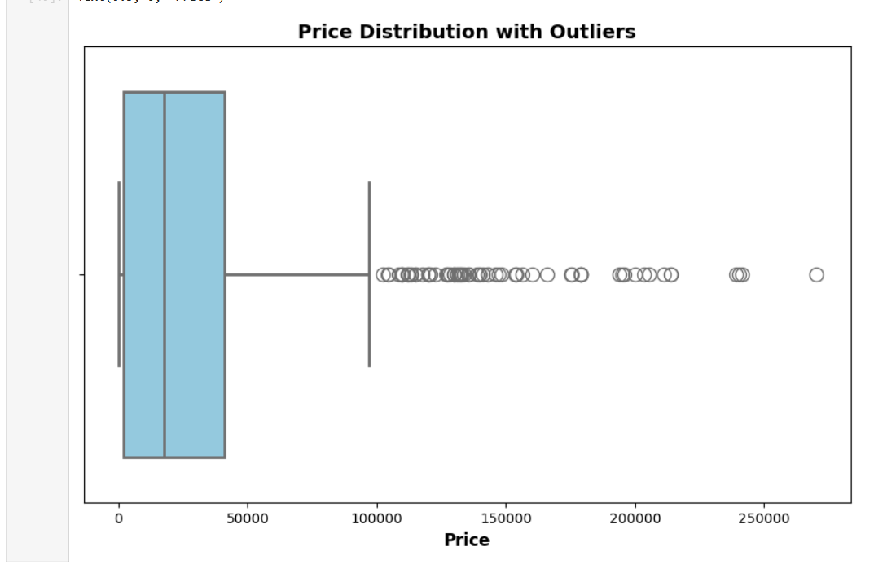

5.4 Data Storage
- Designed a relational database schema.
- Used SQL Alchemy to connect Python with the database.
- Stored cleaned and structured data into SQL tables.
- Enabled efficient querying and reusability for modeling
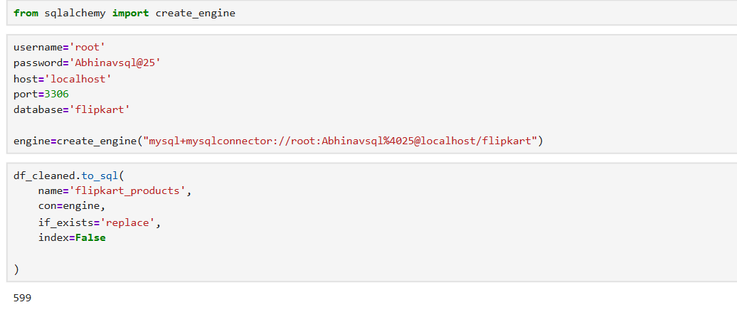
6. Unsupervised Learning(Clustering)
The objective of the unsupervised learning phase was to discover hidden patterns within the product data and group similar products without relying on predefined labels. Products were clustered based on key features such as price, ratings, and review counts to identify natural groupings that represent distinct market segments. These clusters aid in understanding product positioning, pricing strategies, and patterns of customer engagement.
6.1 Selection of Clustering Algorithm
The K-Means clustering algorithm was selected for this task due to its simplicity, scalability, and effectiveness in grouping numerical data. K-Means partitions the dataset into k clusters by minimizing the within-cluster variance, ensuring that products within the same cluster are more similar to each other than to those in other clusters.
6.2 Feature Selection and Scaling
The clustering process used numerical features such as:
- Product price
- Product rating
- Number of reviews
Since these features operate on different scales (e.g., price values are much larger than ratings), feature scaling was applied using standardization techniques. Scaling ensures that no single feature dominates the clustering process and that all features contribute equally to distance calculations.
6.3 Determining the Optimal Number of Clusters (k)
To identify the optimal number of clusters, multiple values of k were tested.
- Silhouette Score was used to measure how well each product fits within its assigned cluster compared to other clusters. Higher silhouette scores indicated better-defined clusters.
By taking the insights from Silhoutte methods, the most appropriate number of clusters was selected, balancing interpretability and clustering performance.
6.4 Cluster Assignment
After determining the optimal value of k, the K-Means algorithm was applied to the dataset, and each product was assigned a cluster label. A new column named Cluster was added to the dataset to indicate the cluster membership of each product.
6.5 Interpretation of Clusters
The resulting clusters revealed meaningful product groupings such as:
- Low-Price Products: Cluster 0
Products with lower prices, moderate ratings, and more reviews. These typically represent budget-friendly or entry-level offerings.
- Mid-Range Products: Cluster 1
Products with moderate pricing, balanced ratings, and average levels of customer engagement. These products generally appeal to a broader audience.
- Premium Products: Cluster 2
High-priced products with higher ratings and a less number of reviews, indicating strong customer trust and perceived quality.

Code:
from sklearn.cluster import KMeans
import matplotlib.pyplot as plt
from sklearn.datasets import make_blobs
from sklearn.preprocessing import StandardScaler
from sklearn.metrics import silhouette_score

# data selection
X=df[['Price','Rating','Reviews']]

#Scaling
scaler=StandardScaler()
X_scaled=scaler.fit_transform(X)

best_k=k[silhouette.index(max(silhouette))]
best_k
# fitting the best_k into kmeans model
kmeans_final=KMeans(
n_clusters=best_k,
random_state=42,
n_init=10

)
df['Clusters']=kmeans_final.fit_predict(X_scaled)

Visualization:
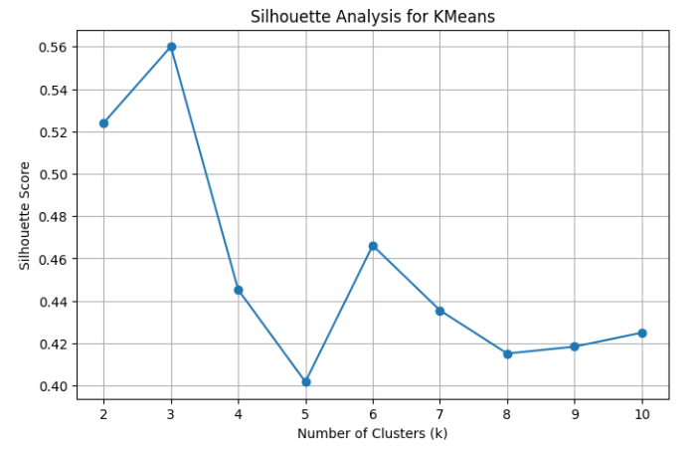
Highest sihouette score = 3
KMeans Clustering
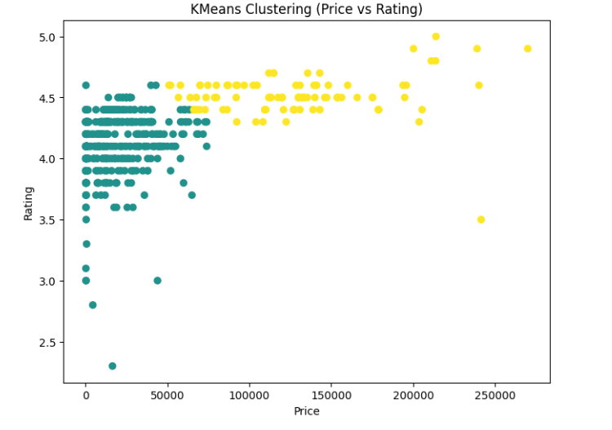

7. Supervised Learning: Product Classification
7. Supervised Learning
The objective of the supervised learning phase was to develop predictive models capable of classifying products into appropriate categories and labels based on their attributes. Using labeled data, the models learn relationships between product features such as price, ratings, and number of reviews, and the target variable. This approach enables automated product classification and supports data-driven decision-making in areas such as inventory management, marketing strategies, and recommendation systems
7.1 Problem Definition
The supervised learning task was formulated as a classification problem, where the goal was to predict a product’s category (or another relevant label) using numerical and encoded categorical features. Historical product data served as the labeled dataset, enabling the models to learn patterns and generalize predictions for new or unseen products.
7.2 Feature Selection and Data Preparation
The following features were used as input variables:
- Product price
- Product rating
- Number of reviews
The target variable represented the product category or class label.
Before training the models:
- Missing values were handled
- Categorical features were encoded and Numerical features were scaled when required
- The dataset was split into training and testing sets to evaluate model performance fairly
7.3 Supervised Learning Algorithms Implementation
Multiple classification algorithms were implemented to compare performance and robustness:

1. Logistic Regression
Logistic Regression was used as a baseline model. It estimates the probability of a product belonging to a particular class and works well for linearly separable data. Despite its simplicity, it provides strong interpretability and fast training.
2. Support Vector Machine (SVM)
SVM was used to find an optimal hyperplane that separates product classes with maximum margin. Kernel functions allowed the model to capture non-linear relationships between features, making it suitable for complex classification tasks.
3. k-Nearest Neighbors (k-NN)
k-NN classifies a product based on the majority class of its nearest neighbors. This model is intuitive and effective for datasets where similar products tend to belong to the same category, though it is sensitive to feature scaling and noise.
4. Random Forest
Random Forest is an ensemble learning method that combines multiple decision trees to improve accuracy and reduce overfitting. It performs well with non-linear data and can handle feature interactions effectively, making it one of the most robust models in this project.
5. XGBoost
XGBoost is a gradient boosting algorithm known for its high performance and efficiency. It builds models sequentially, correcting errors from previous iterations. This model often achieved superior predictive accuracy due to its ability to capture complex patterns in the data.
7.4 Model Evaluation
To evaluate and compare model performance, the following metrics were used:
- Accuracy – Measures the overall correctness of predictions
- Precision – Indicates how many predicted positive instances were actually correct
- F1 Score – Provides a balanced measure combining precision and recall
These metrics enabled a more detailed model evaluation beyond accuracy, accounting for class imbalance.
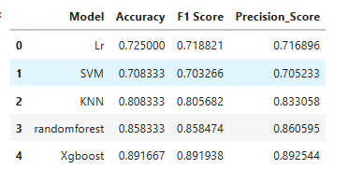
7.5 Results and Model Comparison
Each model was trained on the training dataset and evaluated on the test dataset. Performance metrics were compared across all algorithms to identify the best-performing model. Ensemble models, particularly XGBoost and Random Forest, outperform traditional models by effectively capturing complex data relationships.
8. Hyperparameter Tuning and Model Optimization
The objective of hyperparameter tuning was to enhance the accuracy and generalization capability of the supervised learning models used in this project. In particular, XGboost models were optimized to achieve the best possible performance on Flipkart product data, while minimizing the risks of overfitting and underfitting.
8.1 Hyperparameter Tuning
Default hyperparameter settings are designed for general use and may not be optimal for a specific dataset. In this project, hyperparameter tuning was essential to:
- Improve classification accuracy
- Control model complexity
- Reduce overfitting
- Enhance generalization on unseen data
8.2 Hyperparameter Optimization Methodology
Grid Search with Cross-Validation was used as the primary optimization technique.
- Multiple combinations of hyperparameters were tested
- Cross-validation ensured unbiased and stable performance estimates
- The best hyperparameter set was selected based on evaluation metrics such as accuracy and F1 score
8.3 Hyperparameter Tuning for Logistic Regression
Parameters Tuned
The following hyperparameters were optimized for XGBoost:
- n_estimators: Number of trees controlling model complexity
- max_depth: Limits tree depth to reduce overfitting
- learning_rate: Controls learning speed and stability
- subsample: Uses partial data per tree to improve generalization
- colsample_bytree: Samples features per tree to reduce overfitting

Code:

from sklearn.model_selection import GridSearchCV

param_grid={
'n_estimators':[100,200],
'max_depth':[3,5,7],
'learning_rate':[0.05,0.1],
'subsample':[0.8,1.0],
'colsample_bytree':[0.8,1.0]
}
GridSearchCV
grid_search=GridSearchCV(
estimator=Xgboost,
param_grid=param_grid,
scoring='accuracy',
cv=5,
n_jobs=-1
)
grid_search.fit(X_train_scaled,y_train)
xg_best=grid_search.best_estimator_
y_pred1=xg_best.predict(X_test_scaled)

print('Final Tuned XGBoost Accuracy:',accuracy_score(y_test,y_pred1))
print('Precision:',precision_score(y_test,y_pred1,average='weighted'))
print('F1_Score:',f1_score(y_test,y_pred1,average='weighted'))

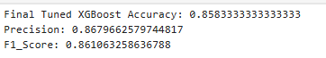

8.4 Analysis and Observations
- Before tuning, XGBoost achieved the highest performance among all models, with strong accuracy, precision, and F1 score, indicating effective learning of complex patterns.

- Hyperparameter tuning using GridSearchCV (5-fold cross-validation) optimized model parameters to improve generalization and reduce overfitting.

- After tuning, accuracy showed a slight decrease, while precision and F1 score remained strong, suggesting better balance between false positives and false negatives.

- The tuned model demonstrates more stable and reliable performance, especially important for real-world data.
- This trade-off indicates that tuning improved model robustness, even if peak accuracy slightly reduced.

8.7 Model Performance Comparison After Tuning
After hyperparameter optimization:
- XGBoost Classifier achieved higher accuracy and F1 score and showed better generalization.
This outcome highlights that Logistic Regression Outperformed and achieved better than random forest

8.8 Final Model Selection
Based on the post-tuning evaluation results, XGBoost was selected as the final model for this project.
Reasons:
- Achieved the highest overall accuracy among all evaluated models
- Demonstrated superior F1 score and precision, indicating balanced and reliable classification performance
- Effectively captured complex relationships in the data through ensemble learning
- Showed strong generalization performance after hyperparameter tuning using cross-validation
Although models such as Random Forest and KNN performed well, XGBoost consistently outperformed them across multiple evaluation metrics. The results highlight that ensemble boosting techniques combined with hyperparameter tuning can significantly enhance predictive performance. Therefore, the tuned XGBoost model was selected as the most suitable and robust model for final deployment.

9. Insights
- Product data was scraped from Flipkart across multiple categories, including mobiles, laptops, electronics, vehicles, and televisions, creating a diverse and large-scale e-commerce dataset.
- The raw data was cleaned and preprocessed by handling missing values, correcting data types, removing inconsistencies, and standardizing numerical features such as price, rating, and review count to ensure data quality.
- A SQL database was integrated to store the processed data, enabling structured storage, efficient querying, and better data management for further analysis and modeling.
- Unsupervised learning was applied to understand inherent patterns in the data.
K-Means clustering was used to group products based on numerical attributes, revealing natural segmentation without predefined labels.
- Silhouette analysis was performed to determine the optimal number of clusters and to validate cluster separation, ensuring meaningful and well-defined groupings.
- The clustering results highlighted clear product segments such as:
  - Price-driven clusters distinguishing budget, mid-range, and premium products
  - Clusters with high customer engagement (high review counts) versus low engagement but high ratings
  - Category-independent groupings showing similar customer behavior across different product types
- After identifying clusters, the problem was extended to supervised learning by using the clustered data and engineered features to build predictive models.
- Five supervised machine learning models were trained and evaluated using accuracy and F1-score, enabling an objective comparison of model performance.
- Among the evaluated models, XGBoost demonstrated superior performance, handling non-linear relationships and feature interactions more effectively than traditional models.
- Hyperparameter tuning was applied to XGBoost, resulting in improved predictive performance and better generalization compared to the baseline models.
- A detailed model comparison showed that the tuned XGBoost model outperformed other supervised models in terms of accuracy and overall stability.
- The final solution provides a scalable framework that combines data engineering, unsupervised learning, and supervised modeling to analyze and predict product behavior in an e-commerce environment.
10. Conclusion
This project implemented an end-to-end data pipeline for analyzing Flipkart product data across multiple categories. The data was scraped, cleaned, preprocessed, and stored in a SQL database for structured access. K-Means clustering was applied to identify inherent product groupings, with silhouette analysis used to validate cluster quality.
Following cluster discovery, supervised learning models were trained and evaluated. Five models were compared using accuracy and F1-score, with XGBoost achieving the best performance. Hyperparameter tuning further improved the model’s predictive accuracy. The project demonstrates effective integration of data engineering, unsupervised learning, and supervised modeling for scalable e-commerce data analysis.

